

Field Book 3.0 Manual

Figure . Examples of Field Book running on a Nexus 5.

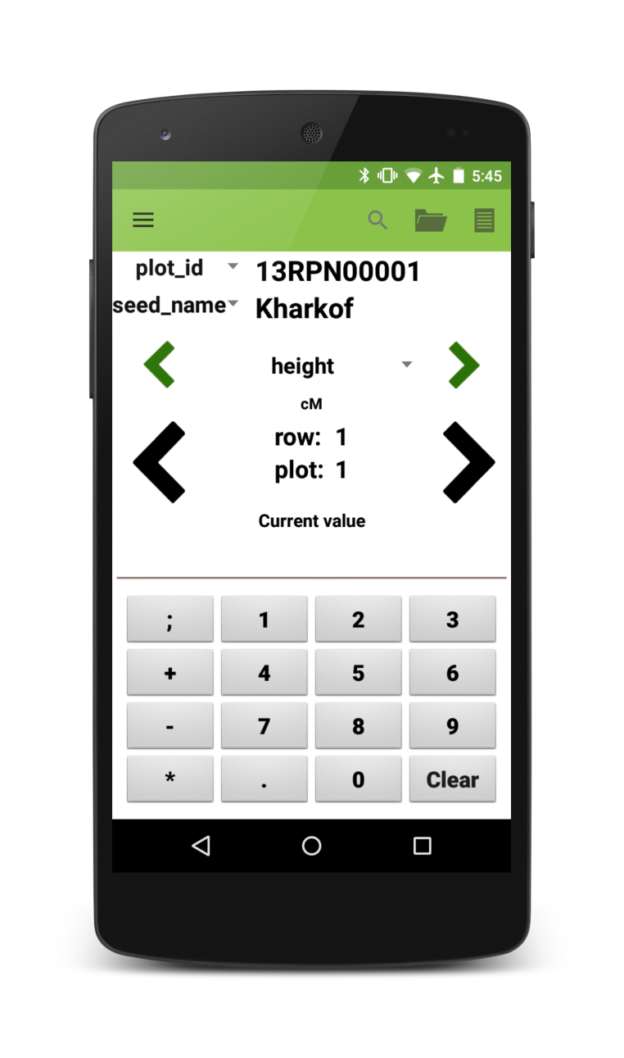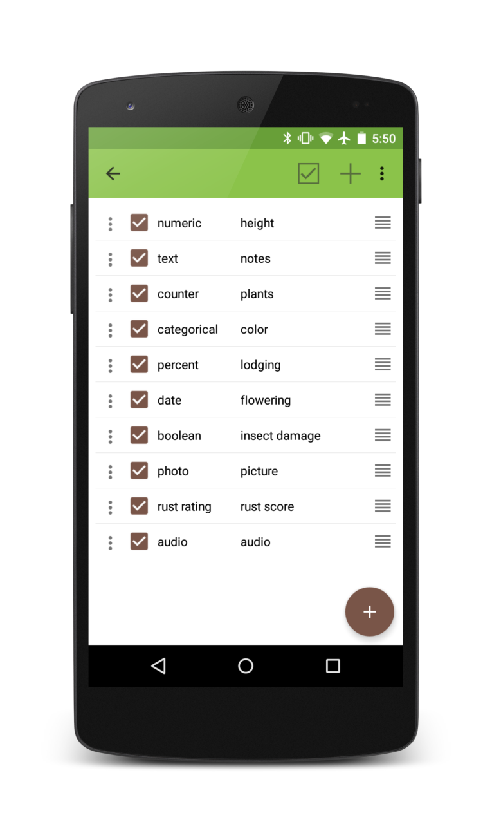

Table of Contents

[Introduction 4](#_Toc428375108)

[Getting Started 4](#_Toc428375109)

[Folder Organization 4](#_Toc428375110)

[Settings 5](#_Toc428375111)

[Fields 5](#_Toc428375112)

[Creating Files 5](#_Toc428375113)

[Transferring Files 5](#_Toc428375114)

[Importing Fields 5](#_Toc428375115)

[Field Example 6](#_Toc428375116)

[Traits 6](#_Toc428375117)

[Creating Traits 6](#_Toc428375118)

[Modifying Traits 6](#_Toc428375119)

[Trait Formats 7](#_Toc428375120)

[Importing and Exporting Traits 7](#_Toc428375121)

[Profile 7](#_Toc428375122)

[Main Screen 8](#_Toc428375123)

[Layout 8](#_Toc428375124)

[Toolbar 8](#_Toc428375125)

[Collecting Data 9](#_Toc428375126)

[Trait Layouts 9](#_Toc428375127)

[Exporting Data 9](#_Toc428375128)

[Export Menu 9](#_Toc428375129)

[Export Formats 10](#_Toc428375130)

[Advanced Settings 10](#_Toc428375131)

[Miscellaneous 12](#_Toc428375132)

[Database 12](#_Toc428375133)

[Languages 12](#_Toc428375134)

[Barcodes 12](#_Toc428375135)

[Hardware 12](#_Toc428375136)

[Contributions 12](#_Toc428375137)

[Acknowledgements 13](#_Toc428375138)

# Introduction

Field Book is an open-source Android app that is used to collect data on field research plots. Past attempts at a digital note-taking tool have relied on spreadsheet layouts which prohibit fast and flexible data entry or have been created for proprietary and expensive hardware, making them inaccessible or uneconomical for most research groups.

By working with an open-source platform and inexpensive hardware, we have created an app that will replace paper field books and their associated transcription errors, and allow current technology to be used in environments where cost and inflexibility have been limiting factors. Furthermore, other groups can customize Field Book’s freely-available source code to their specific use-cases.

The simplicity of Field Book will allow adoption of the app without a steep learning curve. With low-cost, accessible solutions, the vision of one handheld per breeder can become a reality for breeding programs around the world. Transformational capacity in electronic data collection and management will be essential to realizing a contemporary green revolution.

# Getting Started

Field Book can be downloaded from [Google Play](https://play.google.com/store/apps/details?id=com.fieldbook.tracker) on phones and tablets. Upon installation, the app will ask the user if they wish to load sample data and turn on the tutorial. The source code for Field Book is available on [GitHub](https://github.com/trife/Field-Book).

# Folder Organization

Once Field Book has been installed and opened, it will create several folders in the devices memory (Figure 2).

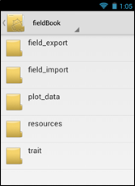

Figure . A list of folders created by Field Book.

* **field\_export :** exported data files are stored in this folder
* **field\_import :** this is the folder that Field Book will look for new files
* **plot\_data :** data associated with plots (audio and photos) are organized into this folder based on the name of the imported file
* **resources :** this folder can hold pictures and files that can be helpful when out in the field and is accessible from the main data collection screen
* **database :** this folder contains files that are exported when backing up the database
* **trait :** this folder contains backed up trait files and the rust rating customizable scale

# Settings

The Settings menu is the main location for configuring Field Book. The options in this menu are used to import files, load traits, change profile information, export data, change the language, and toggle different advanced settings.

This menu will be the first thing that is seen when installing Field Book. Data cannot be collected until both a field file has been loaded and traits have been created.

# Fields

## Creating Files

Field Book can load both CSV and XLS files. Filenames and column headers should exclude the following characters: / ? < > \ \* | ”

Field Book import files should, at the least, include three columns: a unique ID, a primary order, and a secondary order.

Each entry should be assigned a unique identifier. This unique ID is used internally to associate data with a specific entry and should be globally unique. When importing files, Field Book will check to see if the unique ID is unique within the file being imported. In addition, two columns must be included as a basic navigation ordering. These are referred to as the Primary and Secondary Order. The user can select these columns based on how they traditionally walk through the field. Examples of columns that are often used include row and column, range and plot, etc.

Other columns can be included in the field file and can be displayed in the InfoBars on the main screen.

## Transferring Files

Once a field file has been designed, it can be transferred to the Android device via apps like Dropbox or manually with a USB cable.

## Importing Fields

To import files into Field Book, choose the Fields option in the Settings menu. A list of files in the /import\_fields/ folder will be displayed. Selecting one of these files will allow you to assign columns as the unique ID, primary order, and secondary order (Figure 3). Column names cannot contain the text “check”, “insert”, or “update.” Field Book will save the names of the columns used to import a file and autofill them if they exist when importing other files. Field Book uses the same plot order as the imported file.

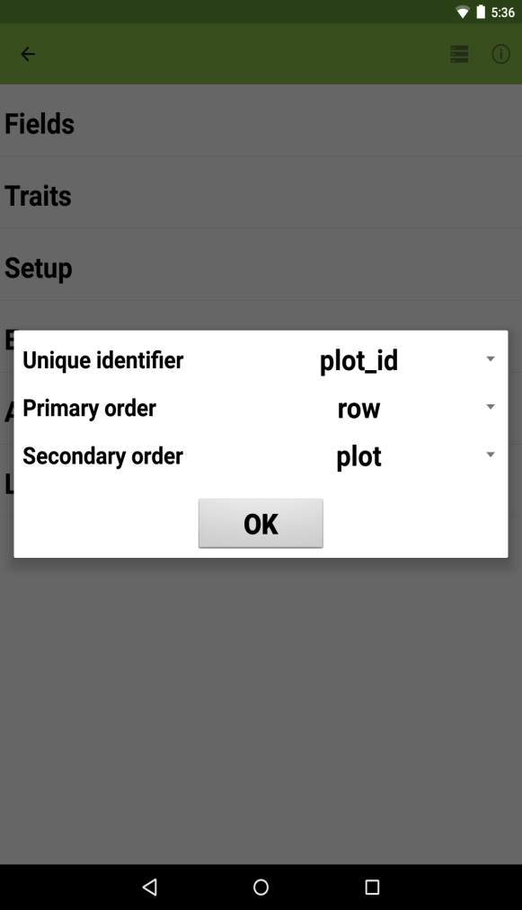

Figure . The dialog that is displayed once a file has been chosen.

## Field Example

Below is a truncated example of the sample field file included with the default installation. In this example, *plot\_id* is the unique identifier, *row* is the primary order, and *column* is the secondary order. The other columns will be visible in the InfoBar section of the main screen.

|  |  |  |  |  |
| --- | --- | --- | --- | --- |
| plot\_id | row | column | seed\_name | pedigree |
| 13RPN00001 | 1 | 1 | Kharkof | Kharkof |
| 13RPN00002 | 1 | 2 | Roughrider | Roughrider |
| 13RPN00003 | 1 | 3 | Nuplains | Nuplains |
| 13RPN00004 | 1 | 4 | Nekota | Nekota |
| 13RPN00005 | 1 | 5 | G980172W | SW/IKE |
| 13RPN00006 | 1 | 6 | G980723 | 94CGT-96HV (BULK SELECTION) |
| 13RPN00007 | 1 | 7 | G980926 W | 95CGT-96WD (BULK SELECTION) |
| 13RPN00008 | 1 | 8 | NW97S412-1 | KS87809-10/ARAPAHOE |

# Traits

Data is collected in Field Book by creating traits. Different trait formats utilize different layouts and features to streamline how the data is collected. The traits screen allows for the management of the current traits within Field Book and lets the user create new traits or modify existing traits.

## Creating Traits

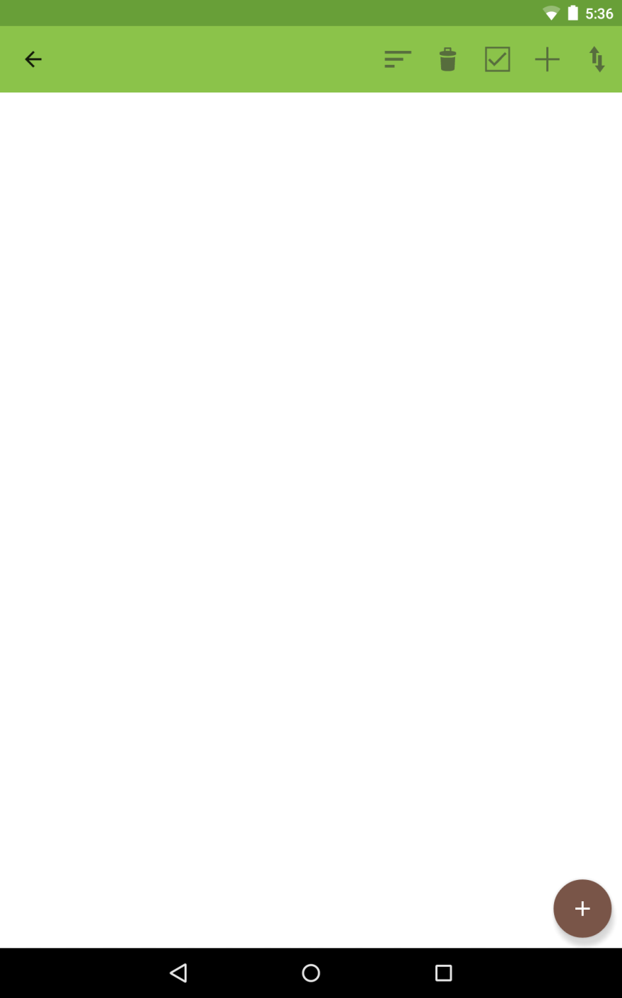

Figure 4. The Add Trait button.

Traits can be created by pressing the brown Add Trait button at the bottom of the screen (Figure 4). Each trait has a custom creation menu that indicates which fields are required. Traits cannot share the same name.

## Modifying Traits

Each trait has options to make data collection easier (Figure 5). The menu icon on each line allows each trait to deleted, copied, or edited. The checkbox allows traits to be active or hidden on the main layout screen. Traits can be reordered by dragging and dropping the icon on the right of each trait line. Traits can also be sorted by their name, format, or active status using the sort icon on the toolbar ( C:\Users\Trevor\Documents\Android\Field-Book\Field Book\app\src\main\res\drawable-hdpi\ic_action_sort_by_size.png ). To make all traits active or hidden, use the checkbox icon on the toolbar ( C:\Users\Trevor\Documents\Android\Field-Book\Field Book\app\src\main\res\drawable-hdpi\ic_action_checkbox.png ).

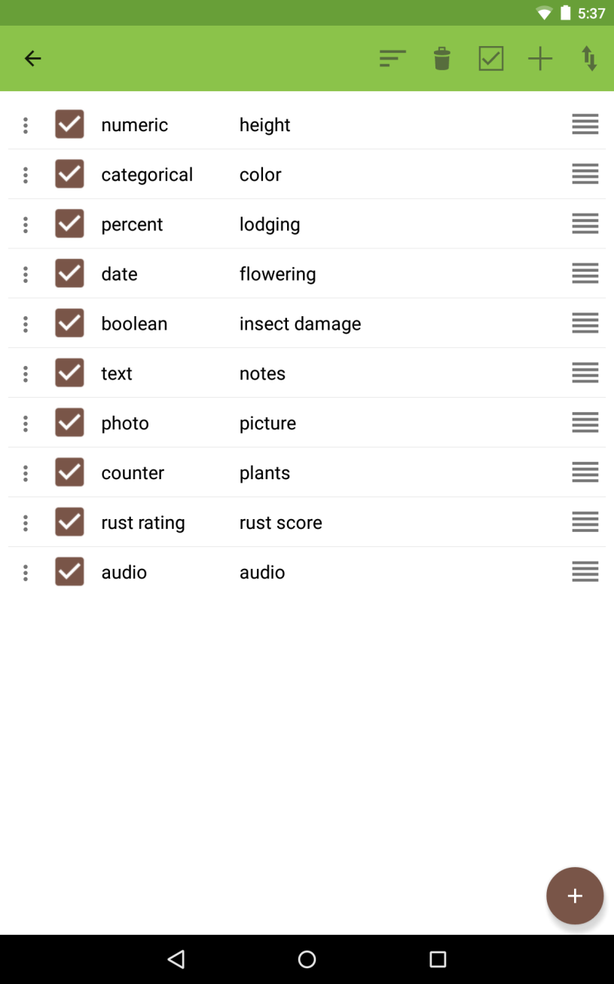

Figure 5. Example of two traits named height and color.

## Trait Formats

Field Book has ten different trait formats available. Different formats have different types of data validation available. For the actual layout, see the layouts in the next section.

**Numeric**

A numeric keypad with additional symbols available.

**Percent**

A percent scrollbar.

**Categorical**

Define up to twelve buttons as different categories.

**Date**

Displays the current date with options to move forward and backward by single days. A No Date option sets the date to Jan 1 2000.

**Text**

Opens the device software keyboard for input.

**Boolean**

True/false button that toggles when pressed.

**Counter**

A plus button that increments the current count value.

**Photo**

Saves a jpg file with the name of the plot and timestamp in the plot\_data folder. Multiple photos can be collected.

**Rust rating**

A disease customizable rating and reaction type scale. The rating scale can be customized by changing the values in the /FieldBook/trait/severity.txt file. Up to 21 different scale values can be defined.

**Audio**

Records an mp3 file that is stored in the plot\_data folder.

## Importing and Exporting Traits

Lists of traits can be created and transferred between different devices using the Import/Export option on the toolbar. Trait lists are stored in the /trait/ folder.

# Profile

The Profile menu allows certain metadata fields to be set. These can be accessed from the main screen using the Navigation Drawer or from the Settings menu.

C:\Users\Trevor\Documents\Android\Field-Book\Field Book\app\src\main\res\drawable-hdpi\ic_person.png **Person**

This records the person collecting data in the field.

C:\Users\Trevor\Documents\Android\Field-Book\Field Book\app\src\main\res\drawable-hdpi\ic_my_location.png **Location**

Location lets the coordinates of the field be recorded. Plot-level coordinates are not currently possible.

# Main Screen

## Layout

**InfoBars**

The InfoBars display information about the current plot and can be customized to show any data that was imported with the field file.

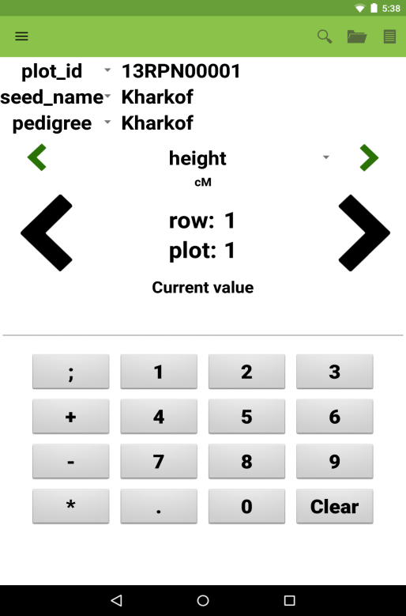

Figure . The layout of the main screen.

**Trait navigation**

The small, green arrows will move between the different traits that are currently active. Pressing the current trait will show a list of all currently active traits.

**Plot navigation**

The large, black arrows will move between different entries. Pressing and holding these arrows will continuously scroll. The longer the arrows are pressed, the faster the scrolling becomes.

**Data input**

The bottom area of the screen is used to input data. Each trait format has a different layout. The elements and layout of this area change based on the trait that is currently active.

**Toolbar**

The toolbar is the green bar at the top of the screen. This area allows quick access to different options and app features.

**Navigation drawer**

The drawer is a menu accessible from the top left of the main screen. It allows the user to access the Settings, Traits, and other options.

## Toolbar

C:\Users\Trevor\Documents\Android\Field-Book\Field Book\app\src\main\res\drawable-hdpi\ic_action_search.png **Search**

Search allows queries to filter data and then move directly to entries in the results.

C:\Users\Trevor\Documents\Android\Field-Book\Field Book\app\src\main\res\drawable-hdpi\ic_action_icon_summary.png **Summary**

The Summary dialog shows all information about a single plot including imported and collected data.

**C:\Users\Trevor\Documents\Android\Field-Book\Field Book\app\src\main\res\drawable-hdpi\ic_action_collection.png Resources**

The Resources dialog allows helpful files like field maps or rating scales to be quickly accessed from the main screen.

**Advanced Settings**

Certain Advanced Settings will add icons to the Toolbar so that the features are readily available while collecting data.

## Collecting Data

To collect data, use the black arrows to navigate to the plot for which data should be collected and navigate to the specific trait you want to collect. The input area at the bottom of the screen will adjust to match the layout of the trait that is being collected. Data is saved to an internal database as it is collected.

## Trait Layouts

Each trait has a specific layout that helps to rapidly collect organized data.

|  |  |  |  |
| --- | --- | --- | --- |
| *Numeric* | *Percent* | *Categorical* | *Photo* |
| C:\Users\Trevor\Desktop\Field Book Manual\Screenshot_2015-08-21-17-38-29.png | C:\Users\Trevor\Desktop\Field Book Manual\Screenshot_2015-08-21-17-38-53.png | C:\Users\Trevor\Desktop\Field Book Manual\Screenshot_2015-08-21-17-38-45.png |  |
| *Date* | *Text* | *Boolean* | *Counter* |
|  |  |  |  |
|  | *Audio* | *Rust rating* |  |
|  |  |  |  |

# Exporting Data

## Export Menu

Collected data can be exported to CSV files. The Export dialog allows the user to customize how collected data is exported (Figure 7). Two different formats can be selected. The export file can include only the unique identifier or all field columns that were imported. The export file can contain all traits currently active or all traits for which data has been collected. The filename is automatically generated based on the current date and the name of the file that was imported into the app.

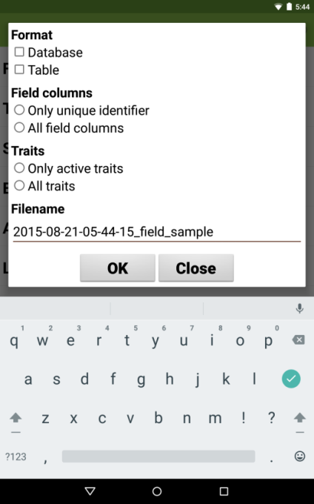

Figure . Export dialog.

## Export Formats

**Database**

Database format exports each individual observation as a row with additional metadata (in green) to indicate the person and timestamp of each observation.

|  |  |  |  |  |  |
| --- | --- | --- | --- | --- | --- |
| plot\_id | seed\_name | trait | value | person | timestamp |
| 13RPN00006 | G980723 | height | 75 | trevor\_rife | 2014.01.09 13:52:32 |
| 13RPN00001 | Kharkof | height | 45 | trevor\_rife | 2014.01.09 13:52:33 |
| 13RPN00002 | Roughrider | disease | Yellow | trevor\_rife | 2014.01.09 13:52:39 |
| 13RPN00003 | Nuplains | disease | Purple | trevor\_rife | 2014.01.09 13:52:39 |
| 13RPN00005 | G980172W | lodging | 27 | trevor\_rife | 2014.01.09 13:52:59 |

**Table**

Table format exports each entry as a row with each trait as a column.

|  |  |  |  |  |
| --- | --- | --- | --- | --- |
| plot\_id | seed\_name | height | disease | lodging |
| 13RPN00001 | Kharkof | 45 | Blue | 42 |
| 13RPN00002 | Roughrider | 23 | Yellow | 51 |
| 13RPN00003 | Nuplains | 63 | Purple | 75 |
| 13RPN00004 | Nekota | 14 | Orange | 57 |
| 13RPN00005 | G980172W | 15 | Black | 27 |

# Advanced Settings

Advanced Settings can be toggled in the Settings menu. Each of these settings adds unique features to Field Book to make data collection easier but is not necessary for the core function of the app.

C:\Users\Trevor\Documents\Android\Field-Book\Field Book\app\src\main\res\drawable-hdpi\ic_action_help.png **Tutorial**

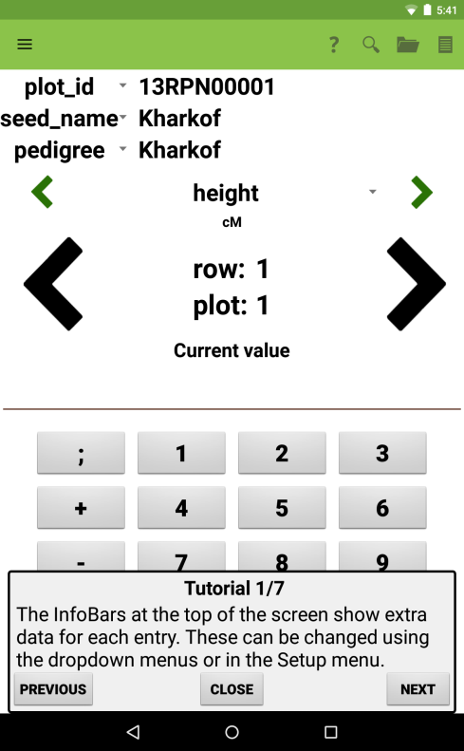

Figure 8. One of the tutorial screens that displays on the main layout.

The Tutorial is designed to provide new users instructions on how to use Field Book. It displays help menus on the main, settings, and traits screen (Figure 8).

**C:\Users\Trevor\Documents\Android\Field-Book\Field Book\app\src\main\res\drawable-hdpi\ic_action_forward.png Enable button to move to next entry with no data**

This button moves to the next plot with no data for the current trait.

**Enable Quick GoTo in the middle of the main screen**

The Quick GoTo changes the middle of the main screen to editable text boxes which can be used to quickly jump to an entry (Figure 9).

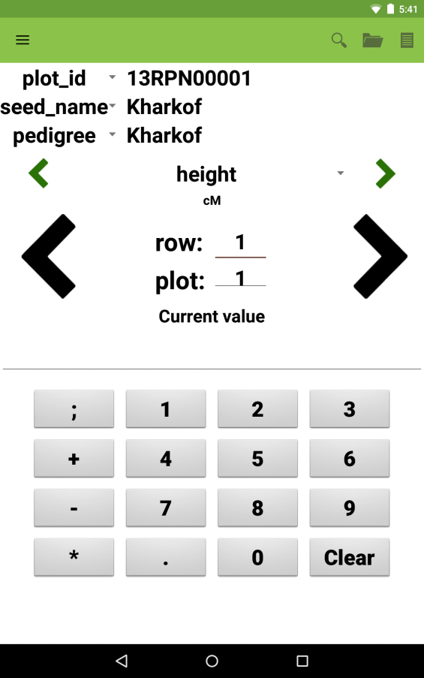

Figure 9. The Quick GoTo enabled.

**Notification sound when primary order changes**

If enabled, the device will chime when the primary order changes while collecting data. This is useful as an indicator to move to the next row of a field.

**C:\Users\Trevor\Documents\Android\Field-Book\Field Book\app\src\main\res\drawable-hdpi\ic_action_barcode_scanner.png Enable button that opens camera to scan barcode**

This will open a barcode scanner app that can scan a unique ID and move the current selection to that entry.

**C:\Users\Trevor\Documents\Android\Field-Book\Field Book\app\src\main\res\drawable-hdpi\ic_action_barcode.png Enables button that moves to specific unique identifier**

This will open a dialog where a unique ID can be typed and move the current selection to that entry.

**C:\Users\Trevor\Documents\Android\Field-Book\Field Book\app\src\main\res\drawable-hdpi\ic_action_grid.png Datagrid**

The Datagrid presents the collected data in a spreadsheet to help identify entries in which data has not been collected. To move to a specific entry, press and hold on any cell in the entry row.

**Disable file sharing when exporting files**

When files are exported, Field Book makes it possible to share those files with other apps installed on the device. This option disables that behavior.

**Disable entry arrows if no data is collected**

If the user wishes to force data to be collected for each plot, the user can disable moving between entries unless there is data collected. This setting is available independently for both the right and left plot navigation.

**Cycling traits advanced to next entry**

This option augments the app behavior so that when cycling from the last to the first trait, the app will also advance to the next entry. This is useful when each plot requires multiple measurements to be collected.

**Hide entries with collected data**

This option will skip plots if they contain data for the current trait.

**Use day of year instead of date**

When enabled, Field Book will save the day of year instead of the date when collecting data with date traits. Toggling this setting will not change data that has already been collected.

# Miscellaneous

## Database

The database can be backed up and transferred between tablets. When exporting the database, two different files are exported: one containing the database, and one containing the user settings when the database was exported. To reimport the database, both files need to be present in the database folder.

## Languages

Field Book is available in 12 different languages: English, Spanish, German, Chinese, Hindi, Amharic, Oromo, French, Russian, Portuguese, Japanese, and Arabic. Languages can be changed in the Settings menu.

## Barcodes

Many Android devices are natively compatible with USB barcode scanners. These scanners act as a hardware keyboard and can be used to directly capture data from barcodes into text traits.

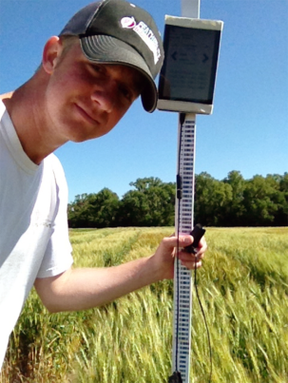

Figure . A barcoded height stick.

Barcoded height sticks have been used to rapidly capture plot height values (Figure 10). Attaching the Android device to the stick makes it possible to accurately capture height without having to handle the device.

# Hardware

Field Book is compatible with Android phones and tablets running Android 4.0 and newer. The devices that are used for development and known to be 100% compatible with Field Book are the Nexus 7, Nexus 5, and Moto G. However, most Android devices will be compatible with Field Book.

# Contributions

Guidelines for making code contributions to Field Book are on the GitHub repository. Ideas for new features can be sent to the development team. If you would like to translate Field Book into an additional language, please contact the development team.

# Acknowledgements

Development Team

* **Trevor Rife**, Developer, Kansas State University
* **Jesse Poland**, Project Lead, Kansas State University

Translators

* **Irazema Fuentes-Bueno**, Spanish, USDA-ARS
* **Sandra Dunckel**, German, Kansas State University
* **Shuangye Wu**, Chinese, Kansas State University
* **Narinder Singh**, Hindi, Kansas State University
* **Daljit Singh**, Hindi, Kansas State University
* **Erena Edae**, Amharic/Oromo, USDA-ARS
* **Tatiana Danilova**, Russian, Kansas State University
* **Rodrigo Pedrozo**, Portuguese, Kansas State University
* **Cristiano Lemes da Silva**, Portuguese, Kansas State University
* **Sophie Bouchet**, French, INRA
* **Hiroyoshi Iwata**, Japanese, University of Tokyo
* **Goro Ishikawa**, Japanese, NARO
* **Khaled El-Shamaa**, Arabic, ICARDA

Support

* The McKnight Foundation Collaborative Crop Research Program
* Rebecca Nelson
* Kansas State University
* Triticeae Coordinated Agricultural Project
* CIMMYT
* USAID
* Bill and Melinda Gates Foundation

